Lab 2: Build and Test a Wired (Ethernet) Network

# Things that you will need to know or learn:

* The correct type of cabling to use when connecting network devices
* How to create an Ethernet (wired) network
* Describe the network components (switch, router)
* Use Packet Tracer to set up Ethernet network

# What a valid IPv4 address looks like; what a valid subnet mask looks like

* How to determine your IPv4 address and subnet masks using **ipconfig**
* How to determine your **Default Gateway** address
* How to verify basic network connectivity using **ping**
* How to copy text from the command line window
* How to use the windows “Snipping Tool” to screen capture and highlight/annotate
* How to use Wireshark to see actual network traffic

# What you need to submit and when:

* Complete the in-lab part of the lab and submit the results on BrightSpace before the due time.
* Complete the “Lab 2 Post-lab” quiz before the due time

# Required Equipment/Software:

Network cables from the instructor (Packet Tracer)

This Lab documents downloaded to your laptop

# Cable Types

* You will be using 2 types of cables; straight through and crossover in PT.
* A straight through cable is used for connecting different (electrically) types of devices (e.g. PC to switch, router to switch)
* A crossover cable is used for connecting “like” devices (e.g. PC to PC, PC to router, router-to-router and switch to switch)

# Task 0: Preparation

**Resource files to study before to do this lab**

* HowToIP_Win7.pdf
* HowToWireShark.pdf
* Cables.pdf
* ICMP.pdf

Note: Do **not start** until you have completed ALL steps in this task.

# Task 1: Build Network with Packet Tracer

In this task, you will build a network, which consists of two computers and a switch (2960). This is the **network topology** on which we will build upon in subsequent labs.

**Devices needed:** Packet Tracer (PT) on your laptop, two PCs, one switch (2960)

**Procedure:**

1-open the PT software

2- Choose two PC (PC0 and PC1) and one 2960 switch.

3- Connect **PC0** to the interface **f0/1** and **PC1** to the interface **f0/2** of the switch (choose the proper cable)

What is the correct cable type to connect the Pcs to the switches’ Ethernet port?

Write it down **Copper Straight Through** (1 mark)

**Note:** If you use the right cable, you should see four **green dots** on the devices

What topology is that? (1 mark)

Write it down **Star Topology**

## **Adding a static IP address to PCs**

1-Double click on the **PC0** and choose **Desktop** tab.

2-Click on the **IP configuration** tab

3-In the **IP address** box type:

IP 192.168.5.3

Subnet mask 255.255.255.0

Gateway 0.0.0.0

DNS 0.0.0.0

Click on **X** to save and close the window.

4-Double click on the **PC1** and choose **Desktop** tab

5-Click on the **IP configuration** tab

In the **IP address** box type:

IP 192.168.5 2

Subnet mask 255.255.255.0

Gateway 0.0.0.0

DNS 0.0.0.0

Click on **X** to save and close the window.

## **How to test PCs connectivity (local network.)**

**Ping** is a command in the **TCP/IP** protocol to test the connectivity between computers.

1-Double click on the **PC0** and choose the **command prompt** box

2-Type C:\ **ping** 127.0.0.1 press enter. You should see four **TTL reply** (Time To Live).

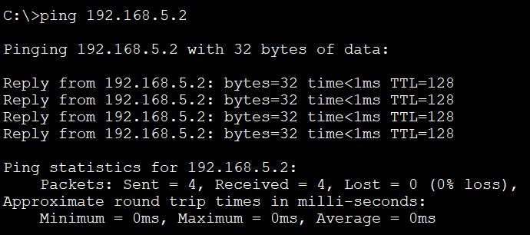

**Note**: The **127.0.0.1** IP address is called **loop back number** and it is used to test the TCP/IP within a PC.

Did you get 4 TTL? **Yes** No

## **Now let us ping another computer on the same network**

First, find the IP address for **PC0.**

1-In the **PC0** go to **command prompt** and type **ipconfig** and press **enter**

What is the IP address and subnet mask for **PC0**? (1 mark)

IP address **192.168.5.3**

Subnet mask **255.255.255.0**

2-In the **PC0** command prompt type C:\ping 192.168.3.9, press **ente**r

Did you get four TTL? Yes or **No**, why (1 mark)

Explain: **Received no packets because ip does not exist on the network**

What is the message **Request timed out.**

Now try to find **PC1** IP address.

3-What is the IP address of the **PC1**?

IP address **192.168.5.2**

Subnet mask **255.255.255.0**

4-From **PC0**, ping IP address of **PC1**

Have you been successful ping **PC1**? (1 mark)

**Yes**  NO

Save the Packet Tracer activity to a file named: **lab2_PT_task1.pkt**

# Task 02: Setting up a DHCP server

What is a **DHCP** server? (Google it) (1 mark)

Explain **DHCP – Dynamic Host Config Protocol:** It assigns all the devices on your network a unique id / IP address that it can be addressed at.

1-Open a new PT

2-Pickup 6 PCs; pc0, pc1, pc2, pc3, pc4, pc5, one server0, one switch0 (2960)

3-Connect all PCs and server0 to the switch0 with the correct cables.

4-Check the IP addresses of PCs. They should be **blank** and no IP address

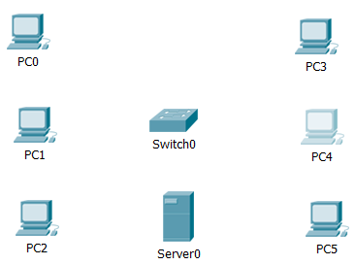

5-Double click on the **server0** and choose **IP address** box

Put a **static** IP address for the **server0**

IP address= 192.168.5.10

Subnet mask=255.255.255.0

Default gateway= 192.168.5.1

DNS=1.1.1.1

6-Now click on the **service** tab and choose **DHCP**

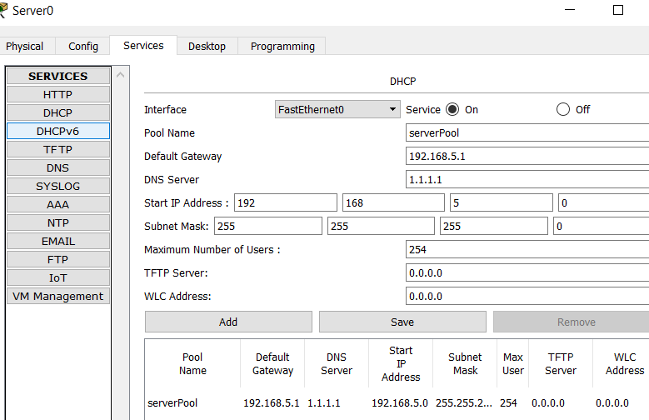

**Note: Start IP address** and the **subnet mask** have already filled up and **maximum number** of users shows **255**

Type:

Pool name= severpool (default)

Default Gateway= 192.168.5.1

DNS=1.1.1.1

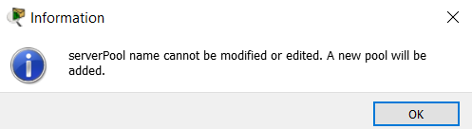

7-Click on **Save** to save the **DHCP pool** settings.

**Note**: you **may** or **may not** get this message; click **ok**

8-Now click **on** service button, to turn on the service

9-click on **X** to close the window.

10- Go back to each PC and click on **IP** box. IP window shows the **Static** option. Click on **DHCP** button and wait for a few seconds. All PCs should have a new IP, subnet mask, Default Gateway and DNS address.

**Note**: to refresh the PCs IP addresses from **static** to **Dynamic** just click on the **static** button and then click on **DHCP** button again.

What is the DHCP pool name?

**serverPool**

What is the IP address of **PC5 (**1 mark)

IP address **192.168.5.6**

Subnet mask **255.255.255.0**

Default Gateway **192.168.5.1**

DNS **1.1.1.1**

Why the default Gateway number is the same for all computers? Google it. (1 mark)

Explain **The reason these are all the same is because we used the DHCP and the protocol uses the same gateway number in order to connect all pcs in the network.**

## **Test the connectivity between PCs (use snipping tools)**

From **pc0,** ping **pc5.** Take a screen capture, save to a file named: **lab2_PT_task2.**

**Save the Packet Tracer file from this task on your computer, you will need to use it for lab3.**

# Task 03: How to copy and paste text in the CMD

1-In your laptop go to **search** and type **CMD**. The **command prompt** window will open.

What is the command to find your laptop IP address?

Write it down **192.168.0.90**

What is the IP address, subnet mask and default Gateway for your laptop? Copy and paste them here. (2 mark)

**IPv4 Address. . . . . . . . . . . : 192.168.0.90**

**Subnet Mask . . . . . . . . . . . : 255.255.255.0**

**Default Gateway . . . . . . . . . : 192.168.0.1**

Note: To copy and paste the text in the CMD, just **highlight the area** that you want to copy and paste it here

# Task 04: How to use Wireshark

WS is a sniffing or analyzing tool that helps to capture packets on the network.

Double click on the WS icon in your laptop and let it run. WS begins to capture packets.

Open your browser. In the URL (Universal Resource Locator) type:

**http://www.algonquincollege.com** and press **enter.**

Now in the WS, click on the RED button to stop it.

You see hundreds of packets, source and destination address, different protocols. Therefore, you can filter the packets by protocol. Under the RED button, there is a long box, type the following filtering conditions:

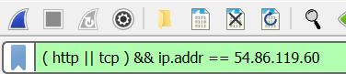

**(http || tcp ) && ip.addr == 54.86.119.60**

The long box becomes green.

Now you only see the packets between your computer and the college website.

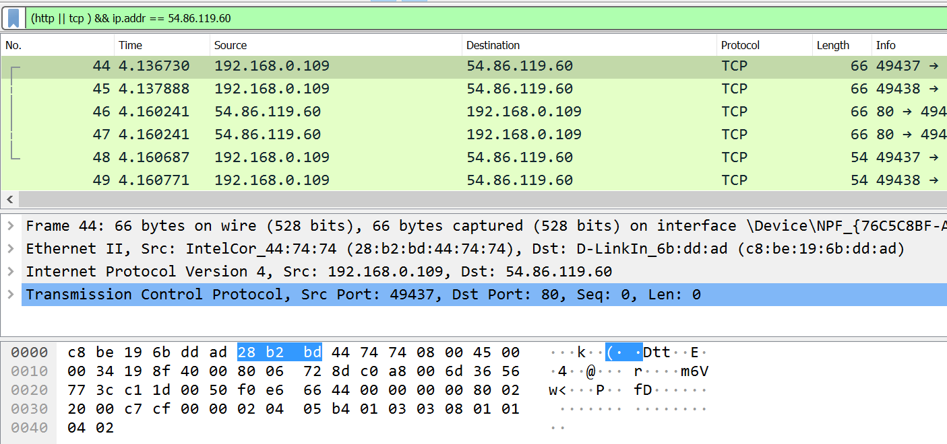

WS has three panes:

Green area shows the NO, Time, Source, Destination, Protocol length, Info

Gray area shows the layer two (data link), frame, Ethernet II for each packet. You can click on each item and read about it more in details.

Black area is the **actual data** in Hexadecimal number.

Save to a file named: **lab2_wireshark_task4.pcapng**

# Task 05: Submission

Submit the saved files from the previous tasks and this Word file to the drop box inside the folder “lab 02” on BrightSpace.